**Review Worksheet Answers: Central Nervous System**

1: Which two large structures make up the Central Nervous System?

(2 marks)

*The Brain (1) and Spinal Cord (1)*

2: Label following structures on the diagram:

(9 marks)

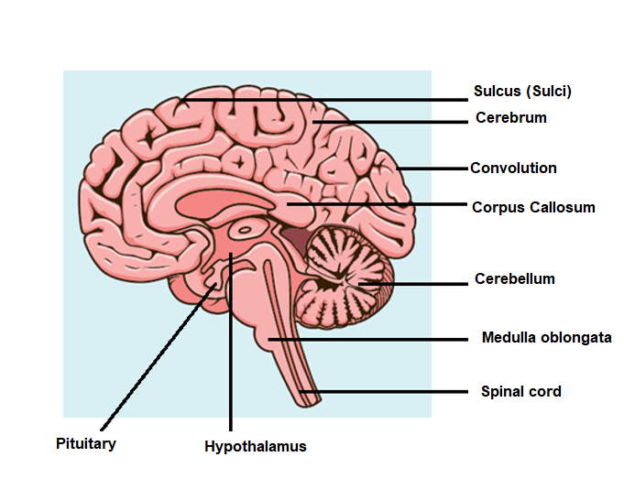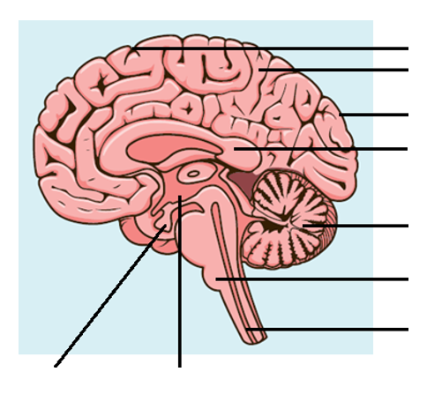

* Cerebellum
* Hypothalamus
* Pituitary
* Cerebrum
* Medulla Oblongata
* Corpus Callosum
* Spinal Cord
* Convolution
* Sulci

3: Fill in the table below to describe the function of each brain structure:

(9 marks)

|  |  |
| --- | --- |
| **Brain Structure** | **Function** |
| Cerebellum | *Coordination and smoothing (0.5) of fine motor movement (0.5). Maintaining posture (0.5) and balance (0.5)* |
| Hypothalamus | *Homeostasis (1) including (2 marks for any 4): regulation of heart, digestive system, appetite, thirst, metabolism, body temperature, response to fear or anger.* |
| Medulla Oblongata | *Works with hypothalamus to regulate heart (1), breathing (1) and diameter of blood vessels.(1)* |
| Spinal Cord | *Provides a pathway of communication between body and brain (1)* |

4: Label the lobes of the cerebrum on the diagram below:

(4 marks)

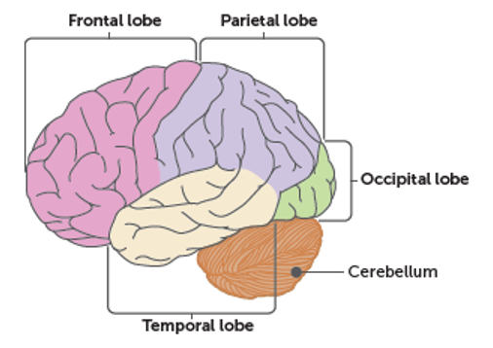

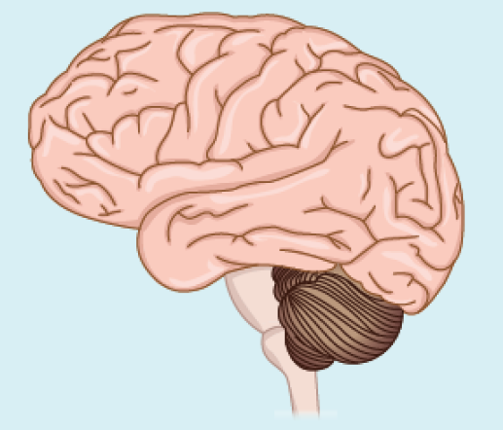

4: What are the main functions of the cerebrum?

(4 marks)

*Thinking, reasoning, learning, intelligence, consciousness (1)*

*Sensory Perception (1)*

*Control of voluntary muscle contraction (1)*

*Memory (1)*

5: What is the white matter in the cerebrum made from?

(1 mark)

*Myelinated axons (1)*

6: Fill in the table to describe the function of each of the areas of the cerebrum and the lobe in which they are located:

(14 marks)

|  |  |  |
| --- | --- | --- |
| **Area** | **Function** | **Lobe** |
| Primary Visual Area | *Receives sensory input from the eyes (1)* | *Occipital* |
| Visual Association Area | *Integrates and organises sensory input from the eyes (1)* | *Occipital* |
| Primary Sensory Area  (from muscles, skin, taste) | *Receives sensory input from muscles and skin (1)* | *Parietal* |
| Sensory Association Area (from muscles, skin taste) | *Integrates and organises sensory input form muscles and skin (1)* | *Parietal* |
| Primary Auditory Area | *Receives sensory input from cochlea (ear) (1)* | *Temporal* |
| Auditory Association Area | *Integrates and organises sensory input from cochlea (1)* | *Temporal* |
| Primary motor area | *Receives input from frontal association area (1) and sends motor signals to voluntary muscles (1)* | *Parietal* |
| Motor association area | *Receives input from frontal association area (1) and prepares for and organises movement (1)* | *Parietal* |
| Frontal association area | *Integrates information from sensory association areas (1), becomes consciously aware of this (1), organises the information (1) and makes decisions (1)* | *Frontal* |

7: A person hiking in the North American forest sees a bear come towards them, then runs away. Write in order, the areas of the cerebral cortex the neural pathway would pass through between when the eye senses the bear and the person runs away:

(5 marks)

*Visual input from the eye would be received by the* ***Primary Visual Area*** *(1)****.*** *This sensory information would be organised by the* ***Visual Association Area*** *(1)****.*** *The neural pathway would then take this information to the* ***Frontal Association Area*** *(1)**where the person would become consciously aware of seeing the bear, and make the decision to run away. A signal would then be sent to the* ***Motor Association Area*** *(1) where the plan for muscular movement would be planned and organised. A signal would then be sent to the* ***Primary Motor Area*** *(1)**which would send information to the muscles to contract so that the person could run away.*

Bonus: what part of the brain would smooth the motor movement and maintain balance and posture after the signal was sent from the primary motor area?

*The cerebellum*

8: What type of white matter tract fibres would be involved in the following situations?

1. Sending information between the spinal cord and cerebral cortex : *Projection Fibres*
2. Sending information between the two sides of the brain: *Commisural Fibres*
3. Sending information between parts of the cortex in the same hemisphere: *Association Fibres*

9: What is the name of the part of the brain that allows the two hemispheres of the cerebrum to communicate?

(1 mark)

*The Corpus callosum*



10: A person who has hyperthyroidism will have low levels of Thyroid Stimulating Hormone (TSH). Explain why this is the case.

(5 marks)

*Hyperthyroidism means that high levels of Thyroxine are produced (1). These high levels are detected by the hypothalamus and pituitary (1). As a result of this, negative feedback (1) occurs, so the hypothalamus decreases production of Thryotropin Releasing Hormone (TRH) and the pituitary (1) decreases production of TSH (1).*